Welcome Desk – InformaStudenti
You can ask for the information you need by writing to the online InformaStudenti service.
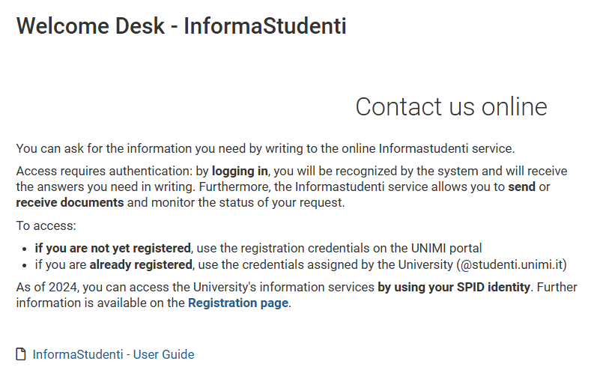
https://www.unimi.it/en/study/student-services/welcome-desk-informastudenti
https://www.unimi.it/it/studiare/servizi-gli-studenti/segreterie-informastudenti
The DOCTORATE SECRETARIAT, for bureaucratic-administrative-career exams-CFU information, can be contacted directly by PhD students through the service:
• InformaStudenti - Postlaurea - Dottorati di ricerca
• The office itself will respond.

